
Applied Science Private University
Faculty of Information Technology

Graduation Project Report

TITLE
PlayMate AutoMate

Prepared by:

Mohammad Kiswani 202010048
Ahmad Serah 202010868
Omar Abu Zir 202011234
Ibrahim Abu Daabis 202011019

Supervised by:
Dr . Marwan Alakhras

June 2024

Copyright © 2023-2024 Applied Science Private University. All rights are reserved

We certify that the work and ideas presented in this project is our own unless referenced.

Name and Signature:…Mohammad Kiswani……………………………
Date:
Name and Signature:…Ibrahim Abu Daabis…………………………….
Date: …………………
Name and Signature:…Omar Abu Zir
Date:
Name and Signature:…Ahmad Serdah
Date:

Contents
List of Figures iii
List of Tables iv
List of Symbols v
Abstract vi
Chapter 1: Introduction 7
1.1 Description of the current situation and opportunity 7
1.2 Related work 7
1.3 Problem statement (limitation of current systems) 7
1.4 Problem solution 7
1.5 Project objectives 7
1.6 Technology and tools used 7
1.7 Project Plan (Gantt chart & PERT chart) 7
Chapter 2: Requirements and Analysis 8
2.1 Software Process Model with explanation 8
2.2 System scope with explanation 8
2.3 Functional Requirements & Non-Functional Requirements 8
2.4 Use Case Diagram with Use Cases descriptions 8
2.5 Activity Diagram for some use case scanrios 8
Chapter 3: Design 9
3.1 Sequence Diagrams for some use case scenarios 9
3.2 Detailed Class Diagram 9
3.3 Database ER Diagram (if applicable) 9
Chapter 4: System Implementation 10
4.1 Main System Screenshots 10
4.2 Important code fragments 10
4.3 List of Non-Implemented requirements and reasons 10
Chapter 5: System Evaluation 11
5.1 System Testing (some test cases) 11
5.2 System Evaluation 11
Chapter 6: Conclusion & Future Work 12
6.1 Conclusion 12
6.2 Future work 12
References 13
Appendix 14

List of Figures

Figure 1: Use-Case Diagram .

List of Tables

Table 1: Code conversion table 7

List of Symbols

Symbols | Meaning

Abstract
The goal of the card-playing robot project is to create an interactive, adaptable robot that can play card games with people. This project aims to create a flexible robot that can interact with players in a smooth and immersive way by integrating hardware and software components. Important features include the ability to recognize cards, make decisions based on player interactions, and communicate with players and the robot through an intuitive interface. By utilizing technologies like Python, Raspberry Pi, and sensor-based input, the project hopes to provide a stable and user-friendly system that improves card gaming while accommodating a wide range of player preferences. When combined with its sequential actions, the robot's capacity for learning and adaptation during gameplay represents a major breakthrough in the field of interactive gaming robotic

Chapter 1: Introduction
The creation of robots as we know them today began in the mid-20th century. In
1954, the first industrial robot, called the Unimate, was created by George Devol.
The machine was tasked with moving die castings from an assembly line and
welding them onto automobile bodies. This was a risky operation for the workers
because they may lose a limb or be poisoned by hazardous vapors if they were not
careful.
The first Unimate was a big box that looked like a computer that was attached to
another box and attached to an arm. It was used for systematic chores that were
stored in a drum memory.
Artificial Intelligence (AI) and robotics are two closely connected disciplines. While
robotics provide a physical platform for AI systems to interact with the outside
world, artificial intelligence (AI) is frequently utilized to govern and enhance the
performance of robots.
Robotics' primary objective is to build machines that can carry out tasks without the
need for human assistance. AI can help accomplish this goal by giving robots the
capacity to sense their surroundings, analyze them, and make decisions based on that
knowledge. AI algorithms, for instance, could be used by a robot that must navigate a
complicated environment to identify barriers, create a route, and prevent collisions.
The first AI program was developed in 1951 by Christopher Strachey, who created a
checkers-playing program for a Ferranti Mark I computer. However, it wasn't until
the 1960s and 1970s that AI research really took off, with the development of new
algorithms and technologies such as machine learning.
In the 1960s, 70s, and 80s, AI research continued to develop, with new
breakthroughs such as expert systems and, a programming language commonly used
in AI research.
In the 1990s, AI software began to take on more practical applications, such as
customer service chatbots and speech recognition software.
Today, AI are ubiquitous in our daily lives, from the algorithms that power our
search engines and social media feeds to the robots that work alongside us in
factories and warehouses.
People are used to seeing bots on webpages and in applications, therefore in this
project we will introduce a physical robot that will connect artificial intelligence and robotics in the entertainment industry. We will accomplish this by playing card
games in a novel way.

Description of the current situation and opportunity
Introducing robots into entertainment platforms presents a remarkable
opportunity to familiarize people, particularly the younger generation, with
these technologies. By crafting engaging and interactive experiences with
robots, we pave the way for individuals to effortlessly interact with and
comprehend these advancements.
Robots tailored for diverse games and activities can act as both companions
and educational aids. For instance, developing robots adept at playing card
games or other intellectually stimulating activities offers a playful
introduction to interacting with robots. Conversely, online platforms like
newspapers and applications such as Jawaker employ bots to play games,
though devoid of human-bot interaction.
Moreover, for individuals on the autism spectrum, these robots can be
invaluable companions, aiding in the development of social and interaction
skills. By providing entertaining and interactive experiences with these
robots, we facilitate a smoother adaptation to and understanding of this
technology.
The fusion of education and entertainment through these robots holds
immense promise. It not only injects enjoyment into the learning process but
also fosters a more comfortable acceptance of technological progress among
individuals.

Related work
Jawaker stands out as a prominent online gaming hub, specializing in card and board games spanning various cultural favorites like Baloot, Tarneeb, Trix, UNO, and more. It enables players to engage in competitive matches against both other players and computer-controlled opponents (bots). Founded in 2009, Jawaker is accessible through its website and mobile applications, ensuring ease and flexibility for users to enjoy gaming across different devices. [1]
Tamatem Games is dedicated to nurturing the Arabic mobile gaming sector to its maximum potential. Through strategies like adapting popular mobile games to suit local preferences, launching original Arabic mobile games, supporting eSports, and investing in the development of Arabic mobile games, Tamatem Games significantly influences the future landscape of Arabic mobile gaming. Their standout titles include Fashion Queen, VIP Baloot, Battle of Kings, and the widely embraced card game, VIP Jalsat.
These platforms serve as online spaces accessible via digital devices such as computers or phones, requiring an internet connection to access the games. Gameplay occurs through a user interface provided by the platform. [2]
Jawaker and Tamatem utilizes artificial intelligence by implementing predetermined rules for its bot functionality. This means that the bot operates within the constraints of these established rules and doesn't actively learn or incorporate new information unless updated rules are introduced.
Chess robot arm
Robot arm that plays chess is a robotic technology that can play board games against people on its own.
The management of the robotic arm manipulator is focused on controlling its position and speed.
The Lab-Volt 5150 robotic manipulator, a robotic manipulator arm with five degrees of freedom (DOF), is to be controlled by a comprehensive control system.
Robots that play chess depend on accurate moves and tactics inside the chessboard's confines.
A smart chessboard is built for tracking opponent’s movement. Board representation and search techniques are provided by using the free and open source chess application the "SharpChess". [3]
table tennies robot arm
A table tennis-playing robot can keep up a rally against humans, but like many amateur players, it struggles when attempting fancier shots.
Yapeng Gao, Jonas Tebbe and Andreas Zell at the University of Tübingen in Germany began by designing a computer simulation in which a virtual robot arm equipped with a table tennis racket attempted to return ping pong balls across a virtual table tennis table.
The researchers ran this simulation so that a machine learning algorithm could learn how the velocity and orientation of the racket affects the path the ball takes.
Once this algorithm, which learns by trial and error, could reliably return the ball, the researchers set it up to control the movement of a real robot arm positioned next to a real table (pictured).
The system used two cameras to track the location of the real ball every 7 milliseconds, and the algorithm processed the signals and decided where to move the robotic arm to hit and return the ball.
The signals that the algorithm sent allowed the robot arm to accurately play shots to within an average of 24.9 centimetres of the intended location. This accuracy level was slightly worse than when the algorithm was working with a simulation – a common occurrence, says Tebbe, as computer simulations can’t accurately represent everything in real life.
The ping pong robot arm is tailored for physical gameplay, focusing on ball
control and movement across a table . [4]

Problem statement (limitation of current systems)
In current card games, the computer-controlled player sticks to a set of rules and can't learn new strategies. Accessing these games requires an internet-connected device like a laptop or phone. However, using these devices might impact people with vision issues due to emitted radiation, affecting a considerable player base.

These games fail to replicate the experience of playing with real people. The computer player's inability to adapt or learn like humans diminishes the excitement of the game. This limitation removes the thrill of unexpected moves and smart strategies that make card games enjoyable. Thus, beyond technical concerns, these games lack the authenticity and excitement that players seek.

Problem solution

The provided solution introduces an interactive robot designed to participate in various card games alongside human players. Additionally, having this adaptable robot in the game creates an strangely sense of playing against a remarkably human-like opponent. Its ability to dynamically change strategies and responses mirrors the unpredictable nature of human players, fostering an immersive and lifelike gaming atmosphere. This not only challenges everyone involved but also elevates the excitement and engagement levels, transforming the entire card game into a thrilling and enjoyable experience, akin to playing alongside a skillful human counterpart.

The provided solution features a robot specifically engineered to join in different card games alongside people. This robot is designed to be flexible, fitting into games like bridge, and collectible card games. It's pretty good at understanding and adapting to different game rules, making it a versatile player in the world of card games.

The provided solution offers a robot that continuously learns and improves its card-playing skills. As it engages in games like poker, it becomes smarter about playing its cards by learning from human players' tactics and adjusting its strategies accordingly. This learning process resembles how experienced players adapt their tactics based on observed behaviors during the game.

Project objectives
1. Robot Development: Construct a physical card-playing robot equipped with advanced AI capabilities to engage in various card games with adaptability and learning capacity.

2. Physical Interaction Design: Create a robot design that allows for realistic and intuitive interaction between players and the machine, enhancing the gaming experience.

3. Adaptive Gameplay Integration: Implement AI algorithms within the robot's system enabling it to analyze and respond dynamically to diverse gaming situations, ensuring engaging gameplay.

4. Robust Physical Build: Construct the robot with durability and stability to withstand frequent use while maintaining performance and functionality.

Technology and tools used
Hardware:
Raspberry Pi is chosen in this project.
The selection of Raspberry Pi over Arduino for this project is primarily driven by the multifaceted requirements and the complexity involved in creating a card-playing robot. Raspberry Pi's robust processing capabilities, including ample RAM, superior computational power, and extensive connectivity options, make it an ideal choice. Unlike Arduino, which excels in real-time control and hardware interfacing, Raspberry Pi's capacity to handle multitasking, complex algorithms, and various programming languages aligns seamlessly with the project's demands. The need for advanced AI functionalities, user interface management, and intricate decision-making processes necessitates the processing prowess and versatility offered by Raspberry Pi, making it a superior fit for this endeavor.
Software and Libraries:
Raspbian OS: The official operating system for Raspberry Pi, providing a user-friendly environment for development.
Python: Python is the top choice for this project due to its adaptability, readability, and extensive library support, including TensorFlow and OpenCV. Its straightforward syntax aids code development, crucial for creating a sophisticated card-playing robot with advanced AI capabilities and a user-friendly interface on Raspberry Pi.
OpenCV: A powerful computer vision library used for image processing and recognition, enabling various vision-related functionalities within the project.

Project Plan (Gantt chart, PERT chart)
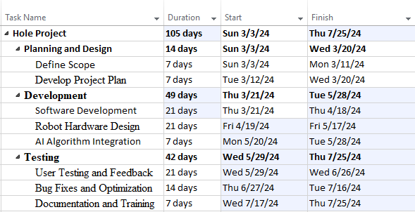
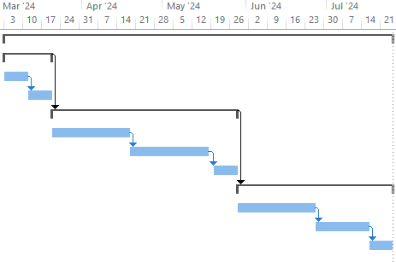
each major step to be completed by (you may decide to include a timeline or Gantt chart).

Chapter 2: Requirements and Analysis

Software Process Model
The software process model that is being used is agile because it enhances customer satisfaction, team performance, and project versatility.
The approach used is called scrum framework; to meet requirements, there are key roles and tasks that must be completed. Product owners, scrum masters, and developers must all be members of the team; each has specific duties throughout the scrum life cycle.
After determining what can be accomplished in a sprint through a meeting known as sprint planning, the product owner begins by gathering requirements from the customer. Then, using best practices, he can order the product backlog. The team collaborates to pull items from the product backlog to create the sprint backlog.
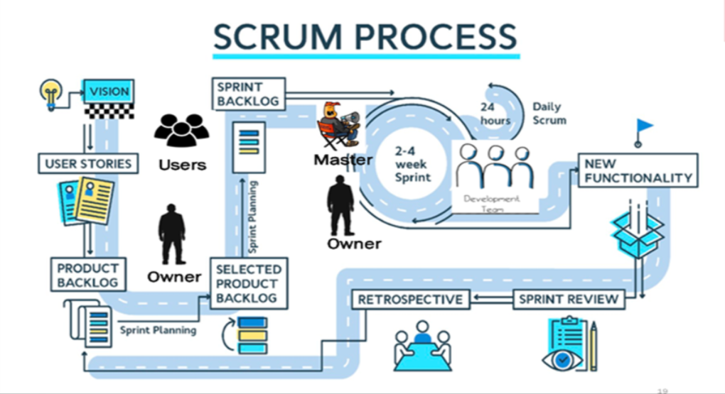

- Planning and Requirement Gathering: The initial phase involves outlining project goals, requirements, and specifications for the card-playing robot. This includes determining functionalities, interactions, and hardware-software integrations required for the project.
- Design and Architecture: Once requirements are established, the design phase begins. This involves creating a blueprint for the robot's physical structure, software architecture, and AI algorithms, considering the compatibility with Raspberry Pi and Python.
- Implementation: With the design finalized, the development phase starts. Python will be utilized to code the functionalities, leveraging libraries like OpenCV for computer vision tasks.
- Testing: Throughout development, testing will ensure the robot operates as intended. This includes testing for individual components, integration testing for hardware-software interactions, and functional testing for the entire system.
- Deployment: After successful testing, the card-playing robot is deployed for usage. This involves installing the software on Raspberry Pi, integrating it with the robot's hardware components, and ensuring its functionality aligns with the project objectives.
- Maintenance and Updates: Post-deployment, ongoing maintenance ensures the robot's smooth operation. Updates and improvements may be made based on user feedback or advancements in technology, keeping the robot up-to-date and functional.

System scope with explanation
Our project initiative includes card players and card-interesting individuals, as well as those who want to play with robots and continuously practice to get better at it. Our goal is to provide gamers with an interactive gaming robot integrated with AI to allow users to test their abilities while also assisting them in acclimating to reality and a challenging environment by providing them with a user-friendly robot-assisted card game, which will excite people's curiosity about the next generation in the entertainment industry.
The physical platform for the card-playing robot project involves the integration of various hardware components to enable its functionalities:
Microcontroller (Raspberry Pi), Sensors (), Communication Board , Mechanical Components.

Integrating AI into the card-playing robot involves implementing these algorithms and frameworks within the robot's software architecture, allowing it to perform tasks such as decision-making, card recognition, learning, and interaction with players autonomously and intelligently.
Customization and personalization features aim to make the gaming experience with the robot more engaging, enjoyable, and tailored to the preferences of individual players, fostering a sense of personal connection and satisfaction during gameplay.
Integrating learning and educational components into the card-playing robot project aims to make the gaming experience not only entertaining but also informative and conducive to skill development and learning, catering to a diverse audience, including educators, students, and enthusiasts seeking an educational gaming experience.
By incorporating community and social engagement features, the card-playing robot project aims to not only provide an entertaining gaming experience but also create interaction, collaboration.

Functional Requirements & Non-Functional Requirements
Functional Requirements:
- The Master user shall insert The battery.

2- The Master user shall press on button to begin work the robot
2.1 the user shall put the robot in a suitable place to start playing with group.
2.2 The user shall press off button to turn off the robot .

3-The Master user shall distribute the cards in an appropriate way to enable robot use cards .
3.1 the user shall distribute 13 cards number to each player.
3.2 the user shall organize the results when ending the game.

4. The user shall communicate with the robot via Board.
4.1 The user shall do one of the following Choices.
4.1.1 users 1 shall choose number between 7 and 12 or 13 or pass and tell the robot the number he chose.
5-The robot shall ensure if all cards are completed by algorithm.
5.1 the robot shall decide whose turn to playing by algorithm
5.1.1 the robot shall determine which card is correct card to play if other players chooses any suits card.
6- the robot shall do 3 steps to complete process of playing.
6.1 the robot shall choose the card it wants to play based on specific algorithm
6.2 the robot shall move his hand to select the card.
6.3 the robot shall raise the card that he chosen.
6.4 the robot shall put the card on playing circle.

Non-Functional Requirements:
- Power Efficiency: Optimizing power consumption to prolong the robot's battery life during gameplay sessions
- Adaptability: The robot should adapt its gameplay based on the skill levels and preferences of different players, providing a tailored experience.
- Maintenance and Upgradability: Facilitating easy maintenance, updates, and potential upgrades to enhance functionalities
- Reliability : Ensuring the robot's consistent and error-free operation throughout extended gameplay sessions.

Use Case Diagram with Use Cases descriptions

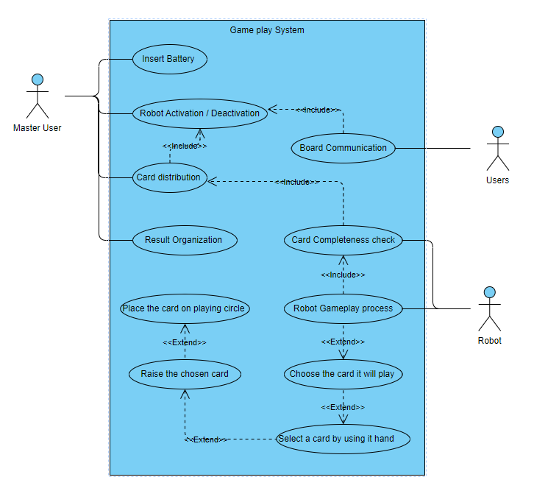

Use Case Name Insert Battary

Description | The Master User inserts the battery into the robot to power it up.
Actor | Master User
Preconditons | The robot is powered off, and the battery slot is accessible
Postconditions | The robot is powered on and ready for operation.
Flow of Activities | Actor | System
Flow of Activities | 1. Master User accesses the robot's battery slot.  2. Master User inserts the battery into the designated slot.
Excptions | 2.1 If the battery is inserted incorrectly, the robot doesn't power on..

Use Case Name Robot Activation and Deactivation

Description | User activates and deactivates the robot.
Actor | Master User
Preconditons | The robot's power system is intact.
Postconditions | Robot is either active or inactive as per user command.
Flow of Activities | Actor | System
Flow of Activities | 1.User presses the ON or OFF button.  2.Robot boots up for gameplay.
Excptions | 1.1 If power issues occur, an error message will appear to User

Use Case Name Card Distribution and Results Organization

Description | User distributes cards and organizes game results.
Actor | User
Preconditons | A complete deck of cards is available.
Postconditions | Players have cards, and game results are documented.
Flow of Activities | Actor | System
Flow of Activities | 1. User distributes 13 cards to each player.
Excptions | 1.1 If the deck is incomplete, an alert asks the user to verify the deck.

Use Case Name Card Completeness Check by Robot

Description | The Robot ensures the presence of all required cards and decides the turn sequence for players through an algorithm..
Actor | Robot
Preconditons | It's the robot's turn in the gameplay sequence
Postconditions | All cards required for gameplay are confirmed present, and the robot has made a decision for its turn based on the algorithm.
Flow of Activities | Actor | System
Flow of Activities | 1.Robot determines its turn using an algorithm.  2. Robot determines the correct card to play if other players choose any suits card
Excptions | 1.1 If cards are missing, the robot pauses the game.

Use Case Name Robot Gameplay Process

Description | During gameplay, the Robot follows a predefined sequence of actions to play a card.
Actor | Robot
Preconditons | It's the robot's turn in the game.
Postconditions | The robot has successfully played the selected card, and the turn proceeds to the next player.
Flow of Activities | Actor | System
Flow of Activities | 1. Robot chooses a card using a specific algorithm.  2. Robot moves its hand to select the chosen card.  3. Robot raises the selected card.  4. Robot puts the card on the playing circle.
Excptions | 2.1 If the robot encounters an error in card selection or placement, it stops the gameplay and signals the Master User to resolve the issue..

Activity Diagram
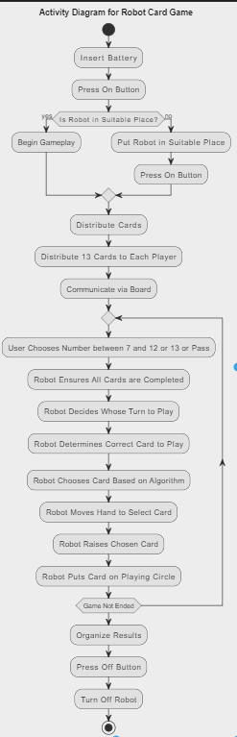

Chapter 3: Design

Sequence Diagrams
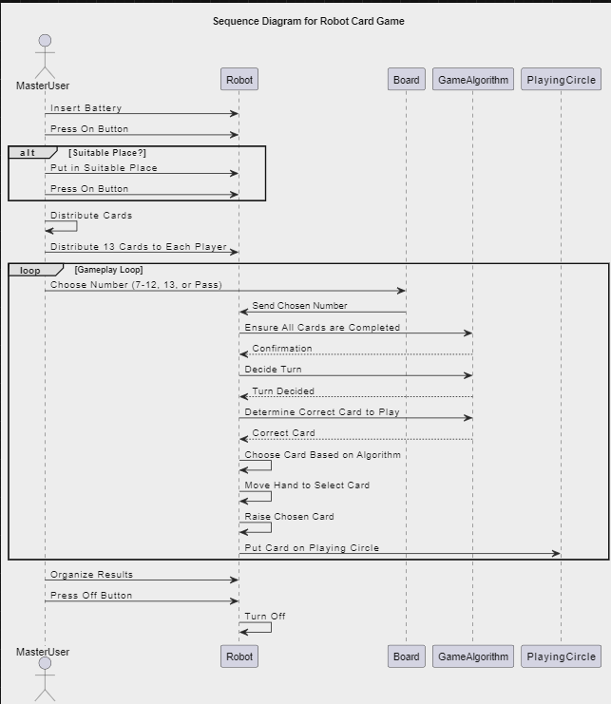

Class Diagram

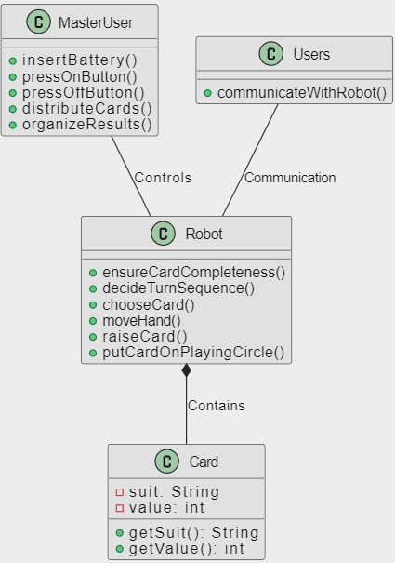

Database ER Diagram
There is no data base for this project

Chapter 4: System Implementation

Main System Screenshots
1-cam
1.1In this project we use a cam for detect a cards by YOLO Model in python


2-Rounds-
2.1After the cam detect the cards it append it into a list that list are the robot cards
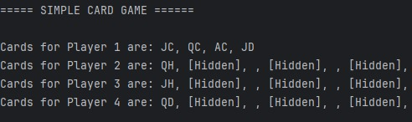

2.2We have second cam to detect in every round the cards are played by the other players
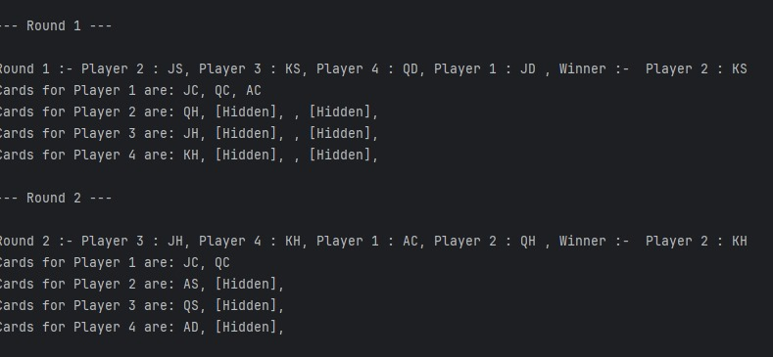

5-This is the complete design before installation
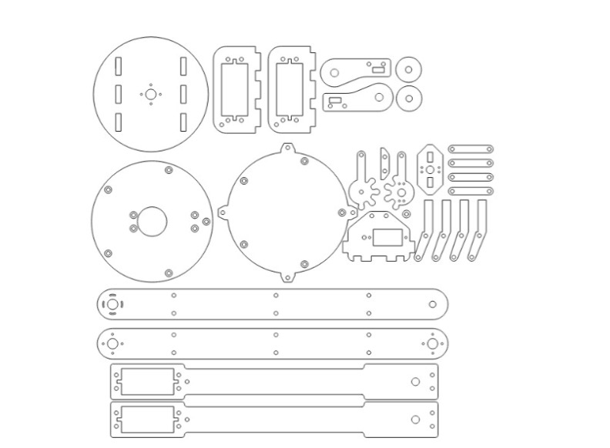

Important code fragments

Initialize the Cams
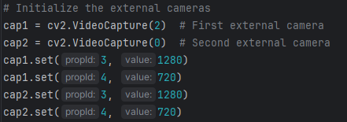

Start the Cam
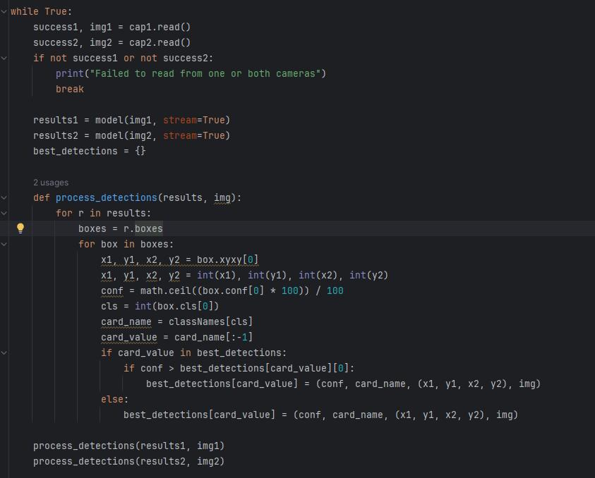

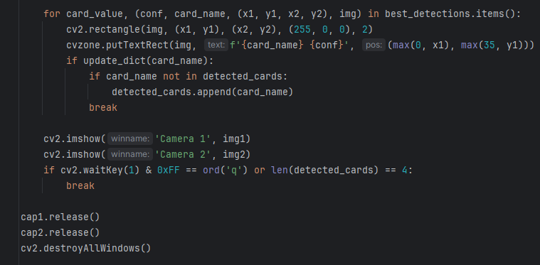

Game Code

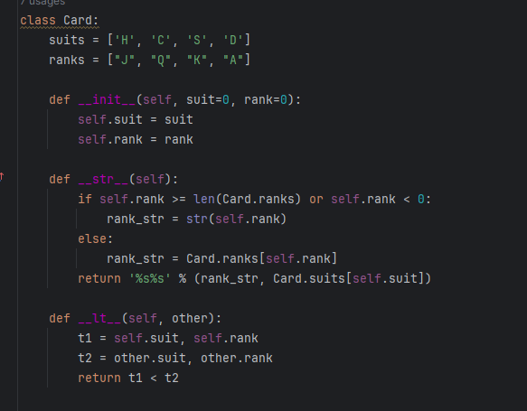

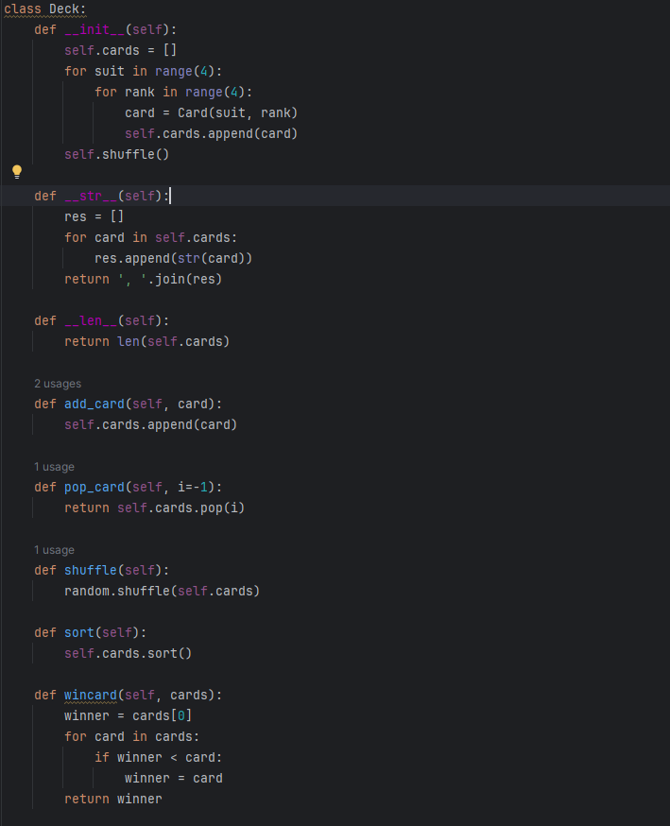

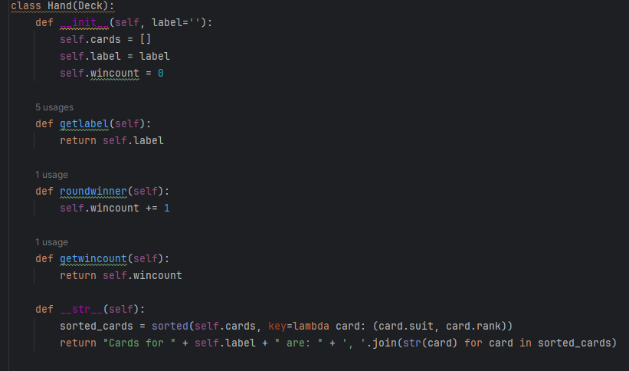

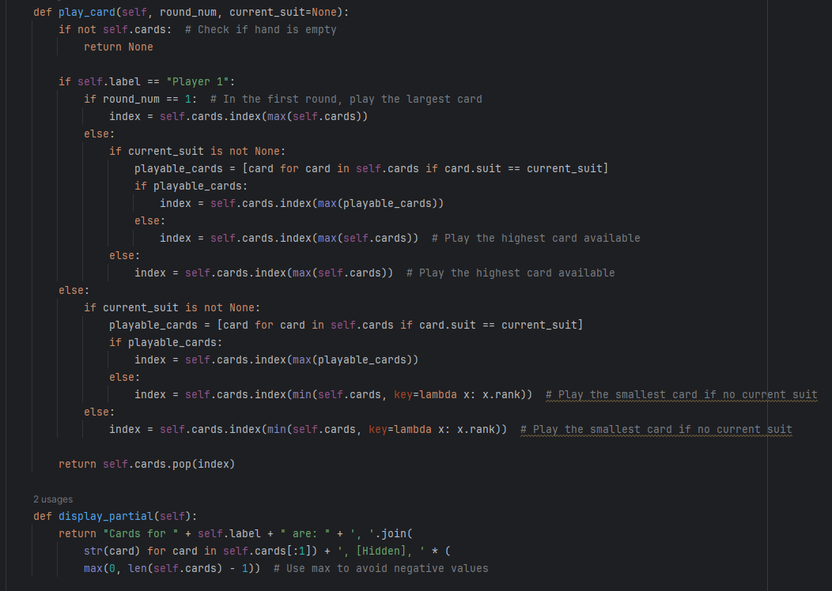

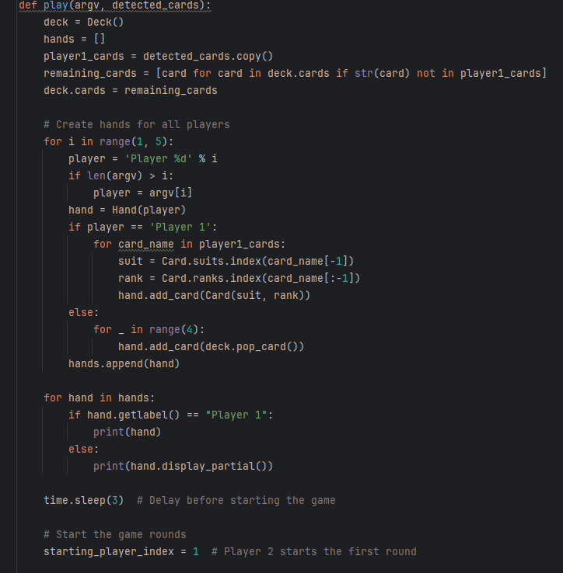

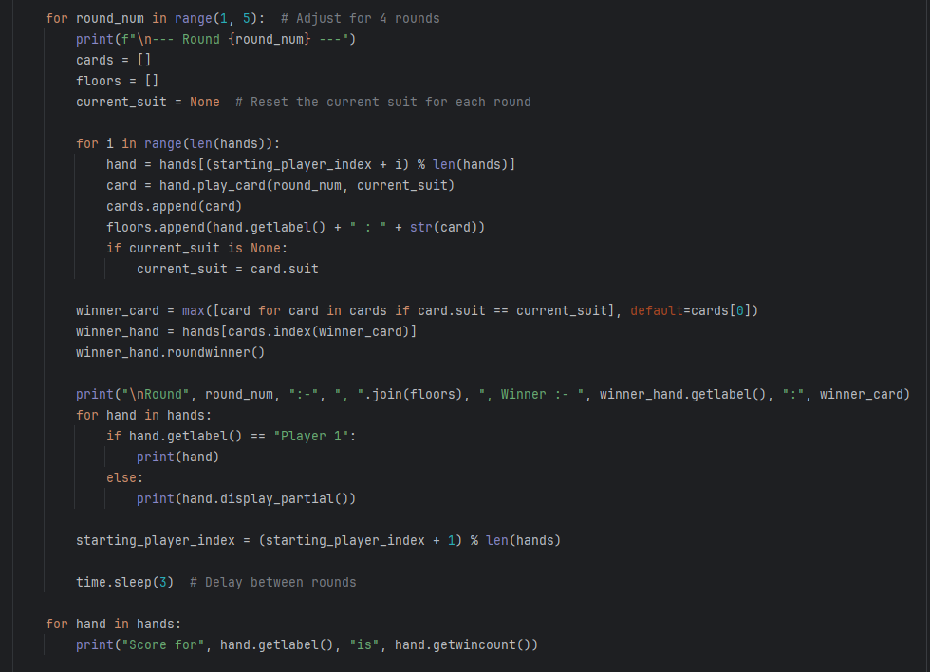

List of Non-Implemented requirements and reasons

1- Due to time constraints and our primary focus on enhancing the robot's playing intensity rather than creating multiple games, we've opted to streamline our efforts. I emphasized the significance of versatility alongside playing proficiency, leading us to choose the development of a straightforward game. This decision allows us to concentrate our resources on refining the robot's skills within a single gaming context while ensuring it remains adaptable to various challenges.

2- Originally, our goal was to develop a robot capable of sequential learning. However, extensive research has revealed the significant time and effort required for this approach. As a result, we focused on simpler and more efficient methods. Our new focus is on inspiring and nurturing the next generation,
immersing them deeply in the subject matter. We begin this journey as the vanguard of the first wave so that they can complete the rest and be able to develop the robot better

-3 Reducing the number of cards from 13 to 6 can definitely simplify the gameplay and make it more intuitive and enjoyable for users. With fewer cards, players may find it easier to focus on the game mechanics and engage their imaginations without feeling overwhelmed by too many choices. This simplification can also lead to faster and more rounds and helps focus on the robot's structures and learn from it.

Chapter 5: System Evaluation

System Testing
- Cam.
1 | Valid | Cam | The camera verifies that the card in question is in the range. | The system shall add the card which detected by the cam into the list. | High | Pass
2 | Valid | Cam | The camera checks whether the image in question exists in the game. | The system shall to be sure if the mage was card. | High | Pass
3 | Invalid | Cam | The camera verifies that the card in question is out the range. | The system shall display the card errors . | High | Pass
4 | invalid | Cam | The camera checks whether the image in question exists out the game. | The system shall display message errors. | High | Pass

Test id | Type | Modul | Description | Expected results | priority | Status

3-Rounds.

Test id | Type | Modul | Description | Steps | Expected results | priority | Status

1 | Valid | Rounds . | Verify that the system correctly starts a new round with 6 cards per player. | 1. Ensure the game is initialized and ready to start a round. 2. Distribute 6 cards to each player. 3. Start the round. | The system should start the round successfully with each player having 6 cards. | High | pass
2 | Valid | Rounds . | Verify that the system correctly detects and processes cards played during a round. | 1. Start a round with 6 cards per player. 2. Each player plays one card in turn. 3. Ensure the camera detects the cards and updates the game state accordingly. | The system should correctly detect the played cards and update the game state. | High | pass
3 | Invalid | Rounds . | Verify that the system handles the detection of a card that is out of the camera's range. | 1. Start a round with 6 cards per player. 2. Attempt to play a card outside the camera's detection range. | The system should display an error message indicating that the card is out of range. | High | pass
4 | Invalid | Rounds . | Verify that the system handles the detection of an image that is not a card from the game. | 1. Start a round with 6 cards per player. 2. Present an image that is not a game card to the camera. | The system should display an error message indicating that the image is not a valid game card. | High | pass
5 | Valid | Rounds . | Verify that the system correctly identifies the end of a round when all players have played their 6 cards. | 1. Start a round with 6 cards per player. 2. Each player plays all their cards. 3. Check if the system correctly identifies the end of the round. | The system should recognize that the round is complete once all cards have been played. | High | pass
6 | Invalid | Rounds . | Verify that the system handles scenarios where the deck is incomplete (less than 6 cards per player). | 1. Attempt to start a round with an incomplete deck (less than 6 cards per player). | The system should alert the user that the deck is incomplete and prevent the round from starting. | High | pass

1 | Valid | Card Recognition  . | Verify correct recognition and identification of cards | System should identify and list all detected cards | high | Pending
2 | Valid | Gameplay Logic | Ensure correct rules and logic during gameplay | System should follow rules and make correct decisions | high | Pending
3 | Valid | Response Time  . | Measure response time from card detection to action | Respond within 2 seconds | Medium | Pending
4 | Valid | Battery Efficiency  . | Evaluate battery life under continuous gameplay | Operate for at least 4 hours on full charge | Medium | Pending

Test id | Type | Modul | Description | Expected results | priority | Status

5.2 System Evaluation

1-Cam

Case 1:

Action | Input | Expected | Actual | Result
Cam 1 | 10 h ,…,…,…,  …,10 D | Pass | Pass | Test is valid
Cam2 | Player1:J h  Player2:k h  Player3:A h | Pass | Pass | Test is valid

Case 2:

Action | Input | Expected | Actual | Result
Cam1 | 10 h ,…,…,…,…,10 D | Failed | Failed | Test is invalid
Cam 2 | Anything except cards | Failed | Failed | Test is invalid

2-Rounds

Case 1:

Action | Input | Expected | Actual | Result
Rounds | Robot:  [A K Q J 10 9] | Pass | Pass | Test is valid
Rounds | Player1:  [A K Q J 10 9]  Player2:  [A K Q J 10 9]  Player3:  [A K Q J 10 9]  All Players have 6 cards | Pass | Pass | Test is valid

Case 2:

Action | Input | Expected | Actual | Result
Rounds | Robot:  [A K Q J 10 9] | Failed | Failed | Test is invalid
Rounds | Player1:  [A K 10 9]  Player2:  [A K J 10 9]  Player3:  [A K Q J 10 ] | Failed | Failed | Test is invalid

Chapter 6: Conclusion & Future Work
It should drive the reader to see that you accomplish your objectives, and you should state any further work recommendations.

Conclusion
Ultimately, we successfully accomplished our objective: the community now has access to physically engaging intense games. This robot's development stemmed from extensive research into the rapidly evolving societal landscape. It offers not only enjoyable gameplay but also a valuable learning experience. Representing a novel endeavor in the contemporary era, it combines entertainment and education seamlessly, enriching the user experience from both perspectives.

Future work
Upcoming Projects: Developing the Arm Robot Card Game The arm robot playing
cards game can be improved in a few ways as we move forward to increase its
functionality, adaptability, and user experience. The following suggestions are for
upcoming work:

1. Improved Algorithms for Machine Learning
Use adaptive machine learning methods to enable the robot to learn from its mistakes
and enhance its gaming over time by evaluating its own actions and results.
Advanced Strategy Modeling: To increase the robot's competitiveness, create
sophisticated models that are able to comprehend and apply intricate strategies that
are employed by professional card players.

2. Enhanced Perception and Sensing
High-Resolution Cameras: To improve card recognition and discern subtle signals or
indications from human opponents, equip the robot with high-resolution cameras to
enhance its vision system.
3D Sensors: By including 3D sensors, you may improve the robot's spatial
awareness, which will allow it to handle cards more precisely and interact with the
gaming environment.

3. Improving Human-Robot Communication
NLP, or natural language processing, Use NLP skills to provide the robot the ability
to comprehend and react to spoken cues from human participants, enhancing the
naturalness and interest of the engagement.
Gesture Recognition: Include gesture recognition so that players can interact with the
robot nonverbally by indicating movements or other activities.

4. Quicker and Craftier Manipulation
Advanced Actuators: Create faster, more sophisticated actuators to increase the
robot's accuracy and speed when handling cards, enabling it to deal and play cards
more smoothly.
Improve the robot's fine motor abilities to handle cards more skillfully, make fewer
mistakes, and move more fluidly overall.

5. The Ability to Play Multiple Games
Game Adaptability: Increase the robot's versatility and entertainment value by
extending its capabilities to accommodate a variety of card games with different
rules and strategies.
Rule Learning: Create algorithms that, with instruction and observation, enable the
robot to pick up new card game rules, eliminating the need for a lot of code.

6. Improved User Interface
Interactive Display: To keep players interested and informed, include an interactive
display that provides game statistics, tips, and suggested strategies.

References
[1] | "jawker," 2009. [Online]. Available: https://www.jawaker.com/en/about.
[2] | "tamatem," 2023. [Online]. Available: https://tamatem.co/news/the-most-popular-card-board-games-in-the-arab-world-and-how-tamatem-can-help-you-play-them/.
[3] | Richard, august 2022 . [Online]. Available: https://www.hackster.io/ricpd/chess-playing-robot-arm-that-will-beat-you-678035.
[4] | C. Stokel-Walker, 10 December 2021. [Online]. Available: https://www.newscientist.com/article/2301254-watch-a-robot-playing-table-tennis-after-just-90-minutes-of-training/.

Appendix

